INTRODUCTION
The Fees Management System is a computer-based application developed using Java for the frontend logic and MySQL for the backend database. It is specifically designed to help educational institutions such as schools, colleges, and coaching centers efficiently manage, track, and monitor student fee records in a secure and organized manner.
In many educational institutions, managing student fee payments manually involves maintaining registers, ledgers, or spreadsheets. These traditional methods are time-consuming, error-prone, and often lead to confusion, delays, or data loss. This project offers a digital solution to these problems by automating the entire fee management process.
The system allows the operator or administrator to perform essential tasks such as:
- Adding new student records with details like name, course, and total fees.
- Recording and updating fee payments.
- Viewing all student records.
- Searching for individual student details using ID.
- Modifying or deleting outdated records.
- Checking pending fees for each student.
All these operations are performed using a menu-driven interface, making the system user-friendly and easy to operate — even for someone with basic computer knowledge.
The primary purpose of this project is to reduce the manual workload on school staff and bring more accuracy, speed, and clarity to the process of fee collection and management. With this system, administrators can access real-time information on how much fee has been paid, how much is due, and by whom — improving decision-making and communication with parents and students.

🎯 Objective of the Project
The main objective of the Fees Management System is to develop a simple, reliable, and efficient application that can:
✅ Digitize the traditional fee record-keeping process.
✅ Minimize errors caused by manual calculations or paper records.
✅ Provide an easy and fast way to add, update, delete, and search student fee data.
✅ Enable quick tracking of fee payments and dues.
✅ Ensure better data security, transparency, and accessibility.
By using this system, educational institutions can save time, reduce paperwork, and maintain a centralized database of all student fee-related information.

📌 Why This System is Useful
- Makes fee management faster and more accurate.
- Suitable for small to medium-sized schools or institutes.
- Can be used by accountants, school clerks, or administrators with minimal training.
- Helps avoid miscommunication or disputes regarding fee payments.
- Can be further improved in the future with features like online payments, SMS alerts, and report generation.

PRACTICAL USE
The Fees Management System is a practical and useful tool for educational institutions to manage student fee records in an organized and error-free way. In real life, many schools, colleges, and coaching centers still use manual registers or Excel sheets to maintain fee details, which can lead to mistakes, confusion, and loss of data.
This project provides a digital solution to such problems by allowing staff to manage all fee-related information through a computer system.

🔧 Key Practical Uses of the System:
✅ Schools & Colleges: The system can be used to maintain the complete fee history of every student including total fees, fees paid, and due amount. It becomes easier for school staff to manage large numbers of students without errors.
✅ Coaching & Tuition Centers: Small coaching classes often struggle with fee tracking. This system helps them manage student data and payments properly, even without advanced technical knowledge.
✅ Office Administrators & Accountants: Staff members can quickly add, update, search, or delete student records. They can instantly check who has paid fees and who hasn’t, saving time and effort.
✅ Easy Record Access: Instead of searching through registers or files, staff can view complete details of any student in a few seconds using the system.
✅ Error Reduction: The system calculates and updates the fee balance automatically, which reduces the chances of manual calculation mistakes.
✅ Paperless Management: It reduces paperwork and promotes a more eco-friendly and modern approach to managing administrative tasks.

Used Softwares
- Java (JDK 17 or above)
Java is a high-level, object-oriented programming language. In this project, it is used to develop the application’s core logic, handle user input, and connect to the database using JDBC (Java Database Connectivity).
- Apache NetBeans IDE
NetBeans is an Integrated Development Environment (IDE) used to write, run, and debug Java programs. It provides a user-friendly interface that makes coding easier and more efficient.
- MySQL Server 8.0
MySQL is a popular relational database management system. It is used in this project to store and manage student data such as names, courses, fee amounts, and payment status in a structured format.
- MySQL Command Line Client
This tool is used to interact with the MySQL database directly through SQL commands. It helps in creating databases, tables, and testing queries manually during development.
- MySQL Connector/J (JDBC Driver)
This is a special Java library (JAR file) that allows Java applications to connect to MySQL databases. It acts as a bridge between the Java program and the database.

Features of Fees Management System in this Project
Each feature is designed to make the process of handling student data and payments easier, faster, and more accurate.

1. Add Student Record
Allows the user to enter new student details such as name, course, and total fees into the system. This data is stored securely in the database.

2. View All Students
Displays a list of all registered students along with their basic details and current fee status. Useful for quick reference and reviews.

3. Search Student
Helps the user find a specific student by entering the student ID or name. This makes it easy to access individual records quickly.

4. Update Student
Enables editing of student information, such as updating name, course, or total fees if changes are needed after registration.

5. Delete Student
Allows the user to permanently remove a student record from the system if the student is no longer part of the institution.

6. Fee Payment
Used to enter the amount of fee paid by a student. The system updates the fee balance and keeps track of payments made.
7. View Due Fees
Generates a list of students who have pending fees. This helps the management in follow-up and fee reminders.

8. Exit
Closes the system safely after the user has completed all tasks. It ensures that the program ends without any data loss.

Text Flow Chart of Fees Management System
┌────────────────────┐
│ Start Program │
└────────┬───────────┘
┌────────────────────────────┐
│ Show Main Menu │
│ 1. Add Student │
│ 2. View Students │
│ 3. Search Student │
│ 4. Update Student │
│ 5. Delete Student │
│ 6. Fee Payment │
│ 7. View Due Fees │
│ 8. Exit │
└────────┬───────────────────┘
┌────────┴────────┐
│ User Choice │
└────────┬────────┘
┌───────────────────┼──────────────────────────────┐
▼ ▼ ▼
Add Student View Students Search Student
(Insert Data) (Display Records) (Search by ID/Name)
│ │ │
▼ ▼ ▼
Update Student Delete Student Fee Payment
(Update Record) (Remove Record) (Update Paid & Due Fees)
│ │ │
▼ ▼ ▼
View Due Fees (Show Pending Fees)
│
▼
Back to Menu
│
▼
Exit Program

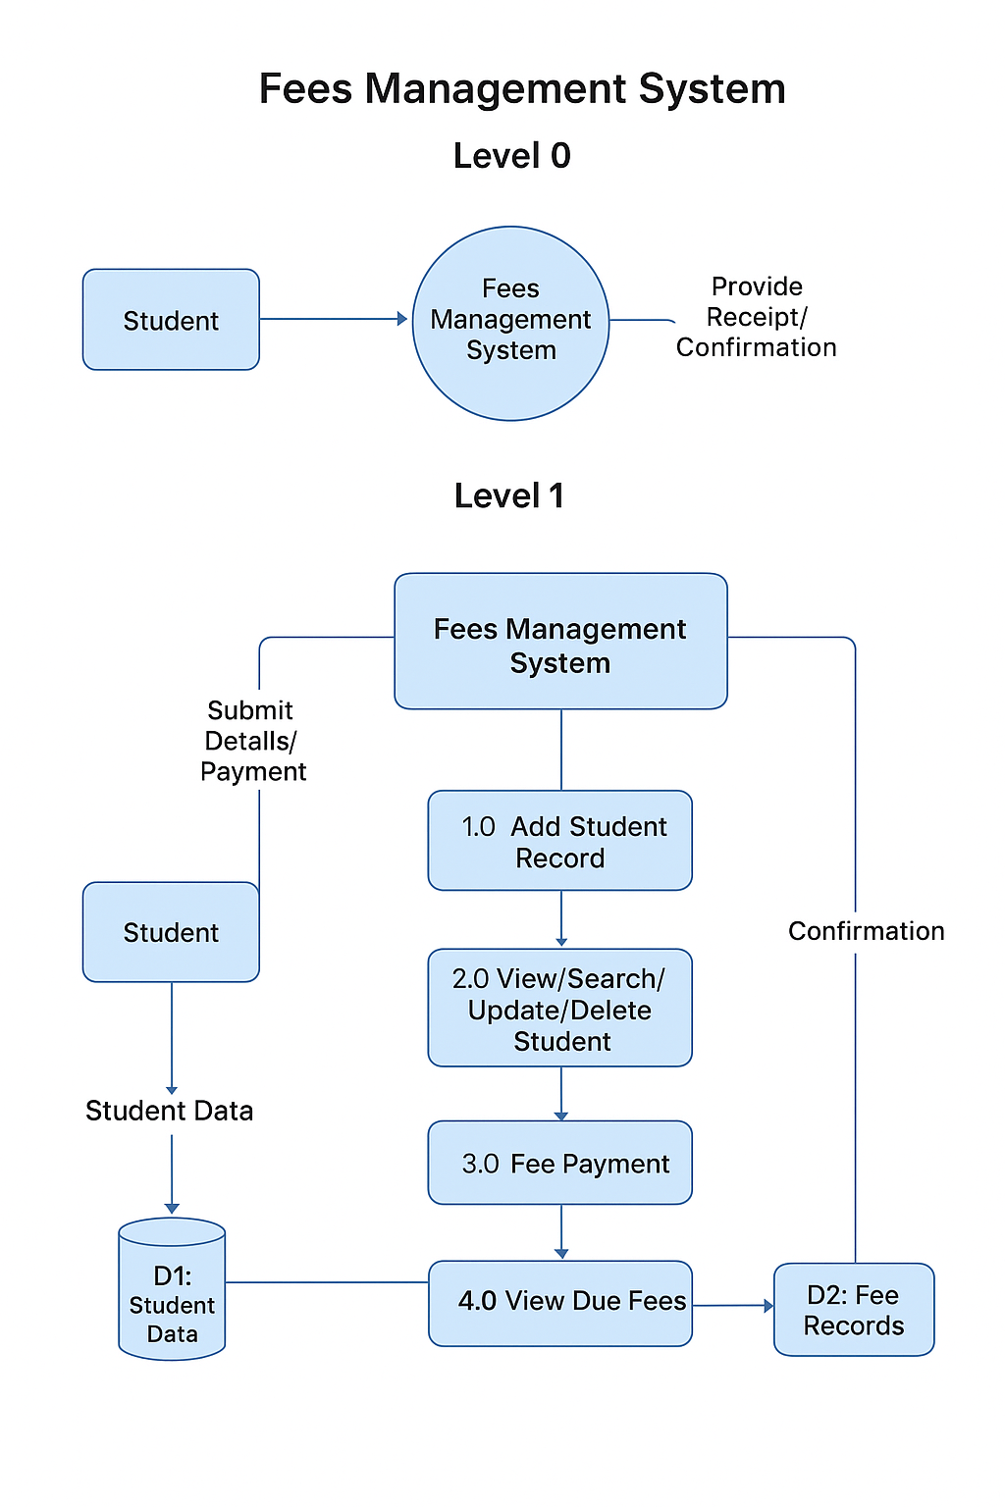
DATA FLOW DIAGRAM
Future Scope

The current version of the Fees Management System is a basic console-based application with limited functionality. However, it can be improved and expanded in the future with the following enhancements:
- Graphical User Interface (GUI): The system can be upgraded from a console application to a user-friendly GUI using tools like Java Swing or JavaFX.
- SMS/Email Notifications: Automated fee reminders can be sent to students or parents through SMS or email for upcoming or pending fees.
- Online Payment Integration: Payment gateways can be added to allow students to pay their fees online securely.
- User Login System: Different login roles like Admin, Accountant, and Student can be implemented for better access control.
- Reports Generation: PDF or Excel reports can be generated for fee collection summaries, due lists, and student records.
- Mobile App Development: The system can be developed as an Android or iOS app for more accessibility.

With these improvements, the Fees Management System can become a fully-featured, professional-grade solution suitable for schools, colleges, and coaching institutes.

Conclusion

The Fees Management System successfully meets its objective of providing a simple and efficient way to manage student fee records. It replaces the traditional manual process with a computerized system, which is faster, more accurate, and easier to maintain.

Using this system, administrators can easily add new students, update records, check fee payment status, and view pending dues. It also reduces paperwork and the chances of human error.

Overall, the project helps educational institutions improve their fee management process and move one step closer to digital transformation in education.

